DAILY ONLINE ACTIVITIES SUMMARY

|  |  |  |  |  |  |  |  |
| --- | --- | --- | --- | --- | --- | --- | --- |
| **Date:** | | **28-05-2020** | | **Name:** | **Suhas prasad shetty** | |  |
| **Sem & Sec** | | **8th B** | | **USN:** | **4AL16CS080** | |  |
| Online Test Summary | | | | | | |  |
| **Subject** | **SMS** | | | | | |  |
| **Max. Marks** | **60** | | **Score** | | **60** | |  |
| Certification Course Summary | | | | | | |  |
| **Course** | | **AWS deepRacer:driven by reinforcement learning** | | | | |  |
| **Certificate Provider** | | **AWS** | **Duration** | | | **90Minutes** |  |
| Coding Challenges | | | | | | |  |
| **Problem Statement:** python program to convert Celsius to fahrenheit | | | | | | |  |
| **Status: completed** | | | | | | |  |
| **Uploaded the report in Github** | | | **yes** | | | |  |
| **If yes Repository name** | | | **Suhas** | | | |  |
| **Uploaded the report in slack** | | | **no** | | | |  |

YOnline Test Details

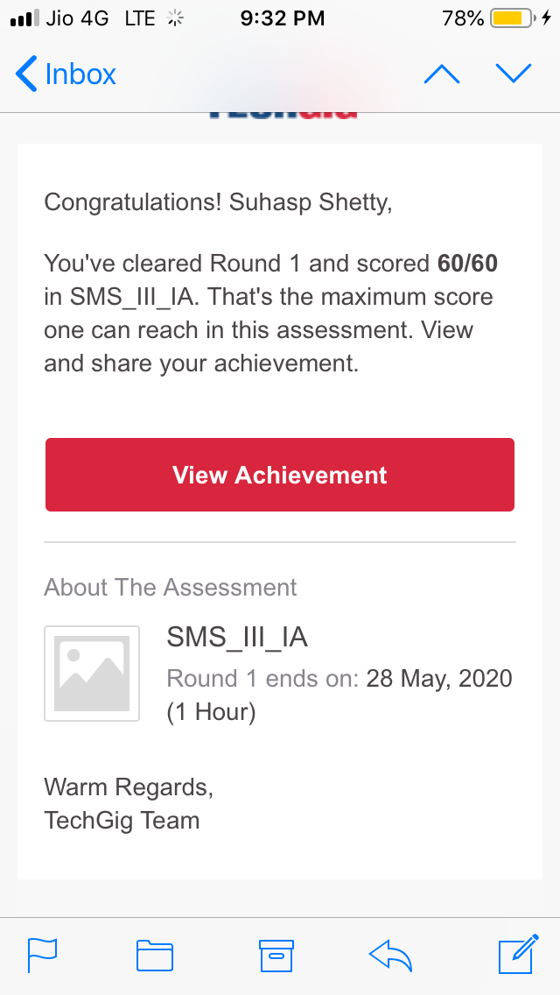

Certification Course Details: (Attach )

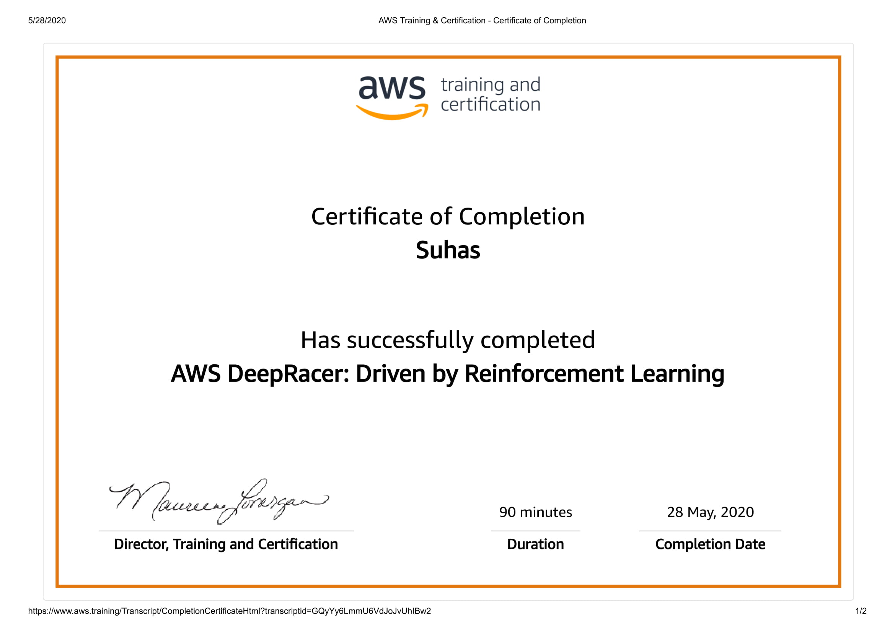

Coding Challenges Details:

Celsius=37.5

Fahreheit = (celsius*1.8)+32

Print(‘%0.IfdegreeCelsiusisequalto%0.IfdegreeFahrenheit’%(Celsius,Fahrenheit))